
DUCHY of CORNWALL

HARBOUR OFFICE, ST. MARY’S, ISLES OF SCILLY
Telephone: (01720) 422768,
e-mail: hm@stmarys-harbour.co.uk
Harbour Master: Dale Clark

PILOTAGE INFORMATION FOR SHIPS MASTERS AND AGENTS

Application

Pilotage is compulsory for the following vessels navigating within the Pilotage District of the Isles of Scilly:
- Vessels over 30.00m LOA (Tug and tows are measured from the bow of the towing vessel to the stern of the towed vessel)
- Within St Mary’s Harbour only, any commercial vessel not normally operating from St. Mary’s Harbour who wishes to access the slipways or beaches within the Harbour limits.
- With the following exceptions:
- His Majesty’s and foreign war ships
- Trinity House vessels engaged in the maintenance of navigation marks
- Trawlers up to 47.50 metres LOA
- Vessels operating under the command of a Pilotage Exemption Certificate holder
- Where, after consultation with the CHA only, a vessel does not intend to navigate within the 50m contour.
- Where, after consultation with the CHA only, a vessel is navigated immediately from a dangerous position to one of safety, when a Pilot is unable to board.
- Deviation from these Directions may be permitted in exceptional circumstances, but only following a formal risk assessment by the CHA.

Limits

The Pilotage District comprises all waters within a 5 nautical mile radius of the Southern end of Samson Island (49° 55.65’N, 6° 21’W)

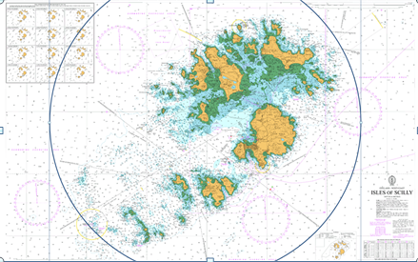.

Pilots

Pilots shall be responsible to the Master and owners of any vessel under pilotage and to the Competent Harbour Authority (CHA), for the provision of proper advice on all matters relating to the safe navigation within the pilotage district.
A Pilot may, at their discretion and taking into account weather conditions and size of vessel, require two pilots.

Vessels arriving from outside the Isles of Scilly may transit that part of the Pilotage District, which lies between the offshore boundary and one of the pilot boarding positions (marked on BA Chart 34) without a pilot on board under the following circumstances:

- The vessel is in VHF contact with St Mary’s Pilot, has obtained permission to enter the Pilotage District.
- The pilot boarding position has been agreed.
- The vessel is approaching directly from seaward along or approximately along a track formed by the extension of the leading line adjacent to the advised boarding position.
- Vessels departing from the Isles of Scilly may transit that part of the Pilotage District which lies between the pilot boarding positions marked on chart BA 34, and the offshore boundary of the Pilotage District, by a route leading directly away from the nearest land (or as otherwise directed by the pilot before or after disembarkation), without a pilot on board.

Notice of Arrival & Pre-Arrival Information

All vessels that are subject to compulsory pilotage shall give at least 24hrs notice to the harbour office.
If the voyage is less than 24 hours duration, the vessel should report their ETA immediately upon sailing from the last port prior to arrival at St Mary’s Pilotage District.
Any subsequent changes should be advised either via email, telephone call or verbally by VHF on arrival.

All vessels are advised that between April and October there are significant amounts of fishing gear in use both close to the shore and in deeper waters around the Islands. Vessels are requested to keep a good look out for these and any other navigational hazards.

Before entering the Pilotage District vessels should ensure they have completed their own pre-arrival checklist which should include testing their bow thrusters (if fitted), be in hand steering mode with a minimum of two steering motors in operation and have their main engines at immediate readiness for manoeuvring.

The Harbour Master may be contacted on VHF channel 14, call sign ‘St Mary’s Harbour’. The Harbour Office is manned daily from 0800 to 1700 April to October and 0800-1700 weekdays during the remaining months.

Boarding Positions

For St Mary’s Sound 49º 53’N 6º 17’W
For North West Passage 49º 56’N 6º 26’W
For Crow Sound 49º 55.5’N 6º 13.5’W

If it becomes apparent that a vessel is steering to approach closer than the agreed pilot boarding position, the pilot shall instruct the vessel to slow, stop or stand away.

Pilot Unavailable

If, for any reason (e.g. sickness), no pilot is available to attend a vessel that is subject to compulsory pilotage, the pilot appointed to the vessel will advise the Harbour Master, who will in turn instruct the vessel to remain outside the Pilotage District until such time as a pilot is available.

Bad Weather

The Pilotage Service shall be suspended during any period of bad weather and/or high sea states if the pilot on turn considers it appropriate to do so.

Pilot Unable to Board / Disembark

Where it is not possible (due to weather or any other exceptional circumstances) for the pilot to board or disembark in the usual position, the pilot may direct the vessel to an alternative position in which boarding or disembarking can safely take place (e.g. on the lee side of the island(s). If this is not possible, in the case of a departing vessel, over carrying should be the preferred option.
Where possible, pilots should review departure passage plans during their attendance on board for arrival.

Over Carriage

Over carried pilots will disembark at the first reasonable opportunity en-route. The charges for over carried pilots shall be equal to reasonable expenses incurred to return to the Isles of Scilly.

Pilot Ladders (Boarding Arrangements)

Vessels are required to provide pilot ladders in accordance with SOLAS and IMPA requirements. In particular, vessels are required to provide a means of access, which involves a vertical climb of not more than 9 metres; this may be achieved by means of a shell door or a combination arrangement with an accommodation ladder. Forward-facing accommodation ladders are not acceptable in this respect and should not be used. Pilot ladders should be rigged so that they are 1m from the waterline

Master/Pilot Information Exchange

On boarding, the pilot should sight the passage plan prepared by the vessel. The pilot will provide a pre-prepared passage plan and discuss this with the Captain along with the MPX form.
The pilot should be provided with a Pilot Information Card in the form recommended in Annex 3 of the ICS Bridge Procedures guide, or equivalent.

Under Keel Clearance

The minimum transiting under keel clearance allowed in any part of the pilotage area is one metre. Due allowance shall also be made for the effects of swell and squat. Normal navigational prudence may dictate an increased clearance, which shall be subject to Pilot advice.
Additional under keel criteria apply for specific Sounds and recognised routes to St Mary’s, which are related to visibility.

Visibility and Under-keel Clearance

In St Mary’s Sound the maximum transiting draught when the leads can be seen shall be 4.7 metres plus the height of tide. If leads cannot be seen, the maximum transiting draught shall be 3.7 metres plus the height of tide.
Vessels may otherwise transit St Mary’s Sound, Crow Sound and the North West Passage at the discretion of the Pilot and Master, taking due account of the navigational preparedness and capability of the vessel.

Buoy Positions

The positions of buoys cannot be guaranteed, particularly in and after conditions of heavy weather. Buoys are a useful check on position but should never be used as a primary means of navigation.

DIRECTIONS

St Mary’s Sound
Currents generally flow along the length of St Mary’s Sound; however, a significant set towards the N Bartholomew and Bartholomew Ledges occurs at times. Also, strong currents often flow across the entrance to the Sound. Actual currents may temporarily exceed the predicted rates and a current chart is shown on BA chart 34.
North West Passage (North Channel)
Details of currents are shown on BA Chart 34. The controlling depth is 12 metres in the channel.

Crow Sound

Details of currents are shown on BA chart 34. The controlling depth is 12 metres (at the anchorage) although a 7.9 metre patch exists off Blockhouse Point.
Note: Transiting of Crow Sound (into or out of St Mary’s Roads) in restricted visibility, is not to be undertaken in any case where the use of St Mary’s Sound is possible as an alternative.

St Mary’s Roads

Anchorage may be obtained in St Mary’s Roads, between Samson Island and St Mary’s Harbour. The anchorage is exposed in winds between SW and NW. Winds from the SW bring in a heavy sea and can render the anchorage unsafe. The holding ground is generally good in depths of more than 6 metres, although poor holding exists in the vicinity of St Agnes Island. A restricted area, shown on the chartlet below, exists over an historic wreck, 4 cables south of Southard Well Point, Samson.

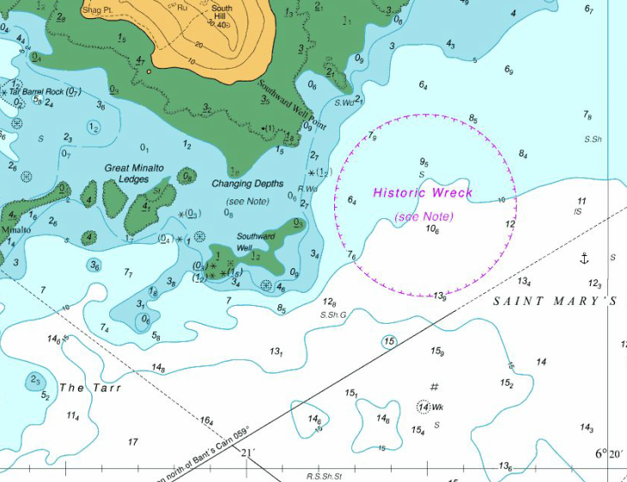

Broad Sound & Smith Sound

The use of Broad Sound and Smith Sound is not generally recommended. Please contact the harbour office for further information.
Anchorages

There are two main anchorages in the Islands for visiting ships – St. Mary’s Roads and Crow Sound. Whilst St. Mary’s Roads is the preferred anchorage, weather and sea conditions may dictate that Crow Sound should be used to provide greater shelter.

